1. Save External into new contour called ‘Skin Surface’

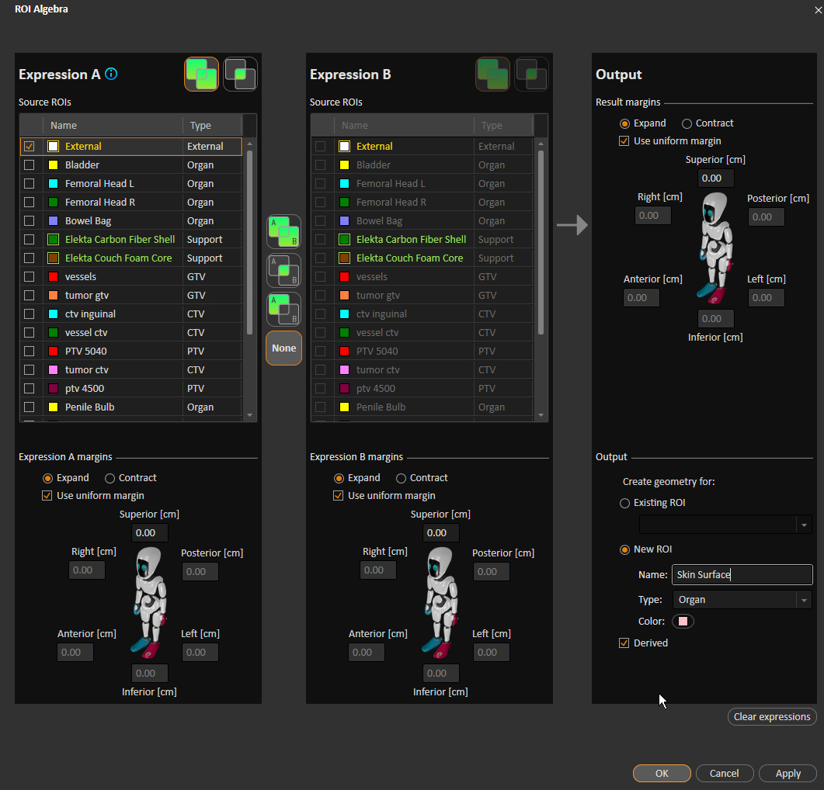

1. Create box contour

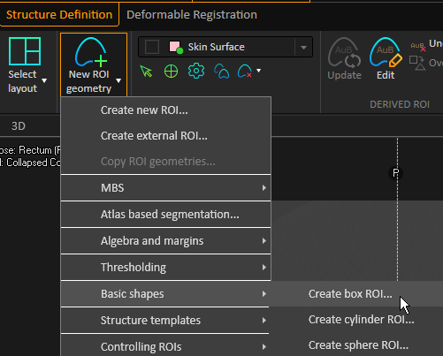

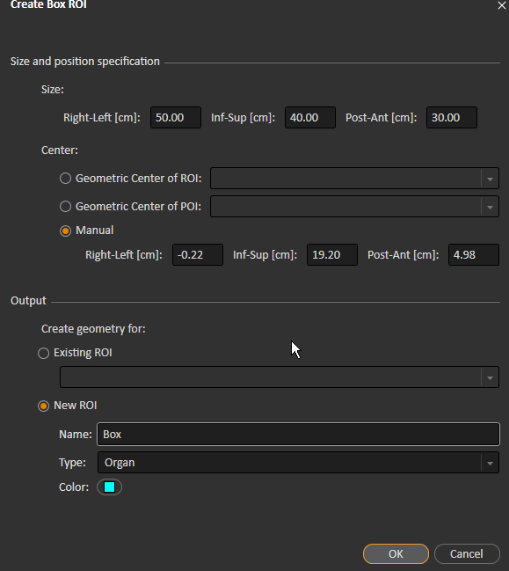

Translate the box to be adjacent to couch.

1. Include box into ‘External’ (using Union function) [Underived]

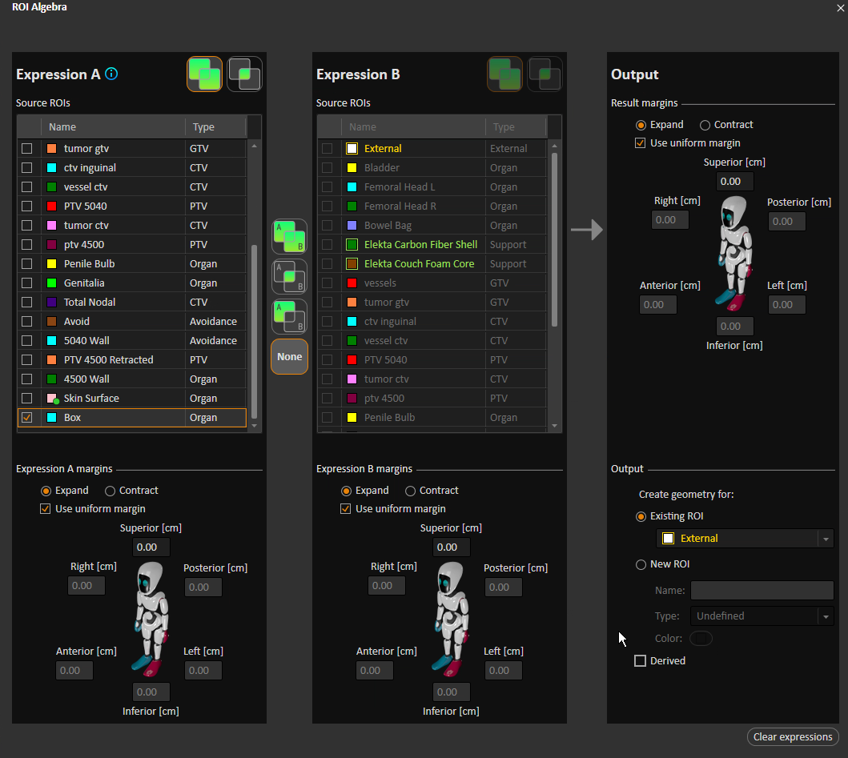

1. Doses will be invalidated, so re-calculate dose, and re-optimize if needed (simply hit continue for 50 more iterations).